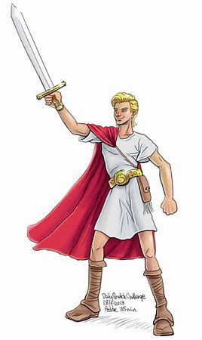

This is the general idea of the young prince with blond hair and a majestic appearance and the cape for a regal effect

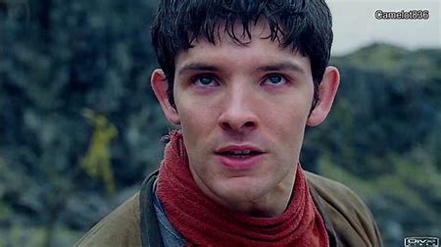

This is a fitting look for the evil wizard as the child-like features invoke a sense of innocence, yet his demeanour suggests malice intentions

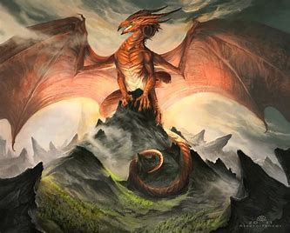

This image was appropriate, as I wanted a majestic appearance with the dragon as well as retaining the stereotypical dragon look.